WEEK 3 DAY 1
TASK 2

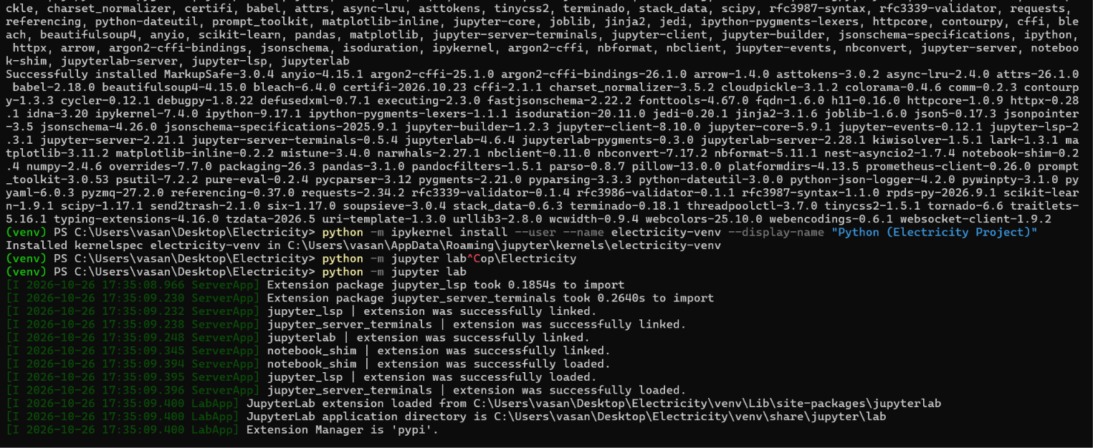

- DESCRIPTIVE ANALYSIS What happened?
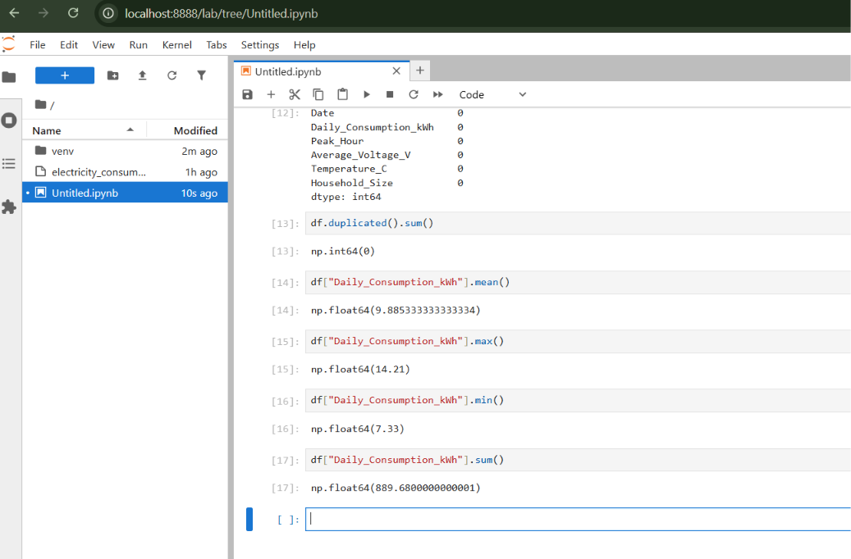

Metric | Result | Interpretation
Total Electricity Consumption | 889.68 kWh | Total electricity consumed over the 90-day period
Average Daily Consumption | 9.89 kWh | Average electricity consumed per day
Highest Daily Consumption | 14.21 kWh | Maximum electricity consumption recorded on a single day
Lowest Daily Consumption | 7.33 kWh | Minimum electricity consumption recorded on a single day
Number of Days | 90 | Total number of daily records analyzed

Key Findings
- Total consumption: The household consumed 889.68 kWh of electricity over the 90-day period.
- Average consumption: Daily electricity consumption averaged approximately 9.89 kWh.
- Peak consumption: The highest daily consumption was 14.21 kWh, considerably above the overall daily average.
- Minimum consumption: The lowest daily consumption was 7.33 kWh, indicating that electricity usage varied across the observation period.
- Consumption variation: The difference between the highest and lowest daily consumption was 6.88 kWh.
The descriptive analysis shows that the household consumed 889.68 kWh over 90 days, with an average daily consumption of approximately 9.89 kWh. Daily consumption ranged from 7.33 kWh to 14.21 kWh, demonstrating variation in electricity usage.

- Diagnostic Analysis Why did it happen?
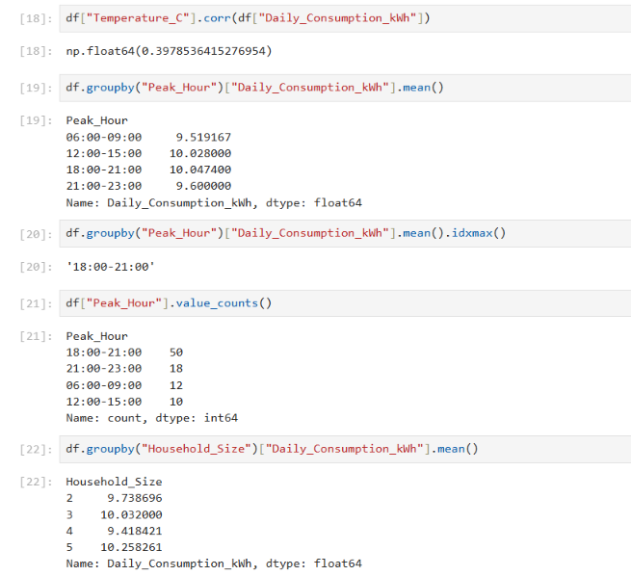
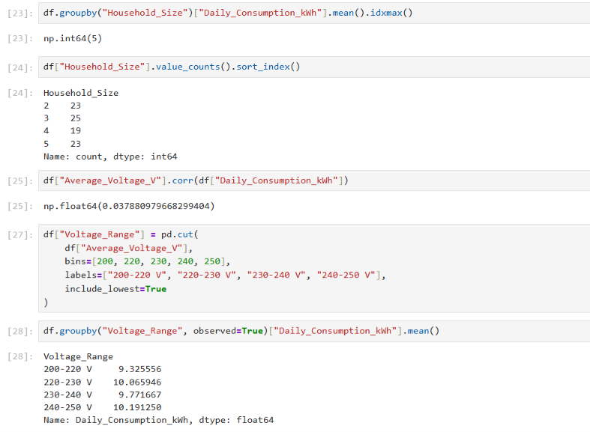

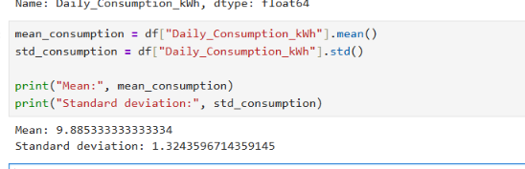

Factor | Result | Interpretation
Temperature | Correlation: 0.3979 | Moderate positive linear relationship
Peak-hour category | Highest average: 18:00–21:00 | Evening category has the highest average daily consumption
Household size | Highest average: 5 people | Consumption does not increase consistently with household size
Average voltage | Correlation: 0.0379 | Almost no linear relationship
Voltage range | Highest average: 240–250 V | Category averages differ, but there is no consistent trend
High-consumption days | Threshold: approximately 12.53 kWh | Values above this threshold warrant investigation

1. Temperature vs Electricity Consumption
Result:
Correlation coefficient = 0.3979
2. Electricity Consumption by Peak Hour
Your results:
Peak Hour | Average Daily Consumption (kWh) | Number of Days
06:00–09:00 | 9.52 | 12
12:00–15:00 | 10.03 | 10
18:00–21:00 | 10.05 | 50
21:00–23:00 | 9.60 | 18

Interpretation:
- The 18:00–21:00 category has the highest average consumption, at approximately 10.05 kWh.
- This category also occurs most frequently, accounting for 50 of the 90 days.
- The 06:00–09:00 category has the lowest average consumption, at approximately 9.52 kWh.
3. Electricity Consumption by Household Size
Your results:
Household Size | Average Daily Consumption (kWh) | Number of Days
2 people | 9.74 | 23
3 people | 10.03 | 25
4 people | 9.42 | 19
5 people | 10.26 | 23

Interpretation:
- Households with five people have the highest average consumption, at approximately 10.26 kWh.
- Households with four people have the lowest average consumption, at approximately 9.42 kWh.
- Consumption does not increase consistently with household size.

4. Average Voltage vs Electricity Consumption
Result:
Correlation coefficient = 0.0379

- Predictive Analysis What is likely to happen?
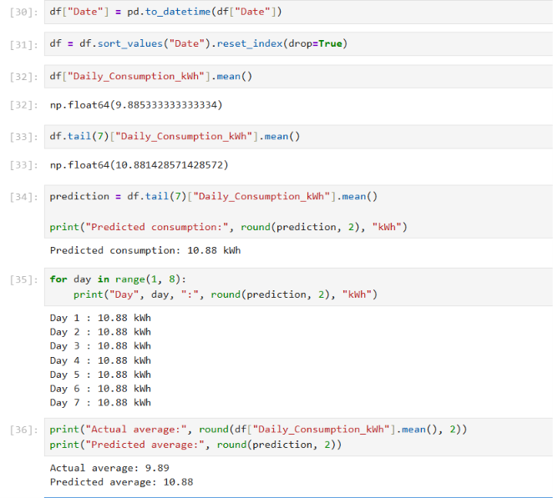

Metric | Result | Interpretation
Overall Average Consumption | 9.89 kWh/day | Average daily consumption across the dataset
Average of Last 7 Days | 10.88 kWh/day | Average consumption during the most recent seven days
Predicted Daily Consumption | 10.88 kWh/day | Estimated consumption for each of the next seven days
Predicted Consumption for 7 Days | 76.17 kWh | Estimated total consumption over the next seven days

Key Findings
- Recent consumption is higher: The average consumption over the last seven days was 10.88 kWh, compared with the overall average of 9.89 kWh.
- Potential increase in consumption: Recent average consumption is approximately 10% higher than the overall average.
- Future consumption estimate: Based on the recent seven-day average, daily consumption is estimated at approximately 10.88 kWh.
- Weekly forecast: If consumption remains at this level, the household may consume approximately 76.17 kWh over the next seven days.

- Prescriptive Analysis What should be done

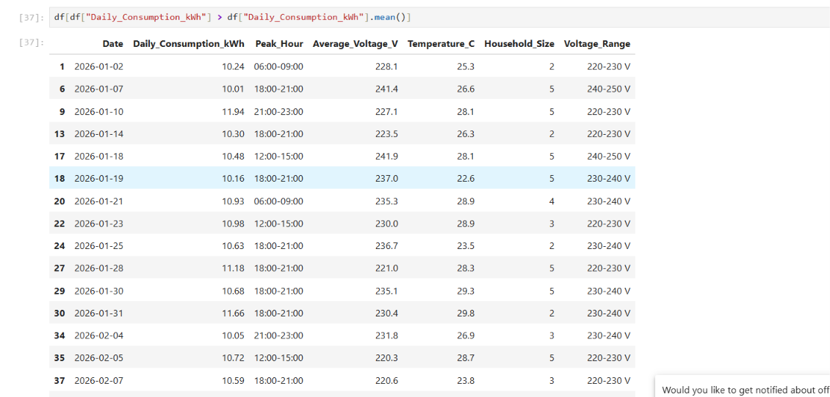
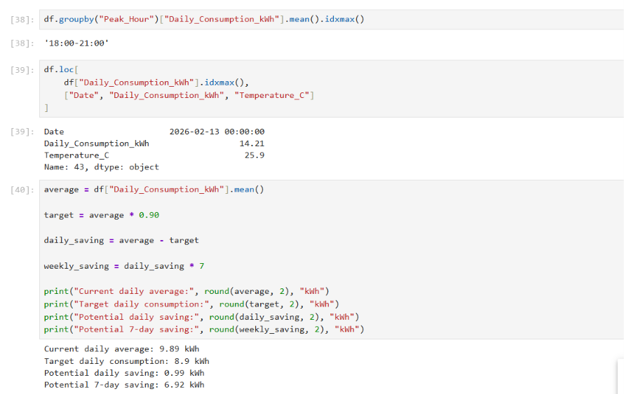

Finding | Recommended Action | Expected Benefit
Average consumption is 9.89 kWh/day | Set a daily consumption target of approximately 8.90 kWh | Aims for a 10% reduction
Evening peak-hour category has the highest average consumption | Review evening appliance usage | May help identify opportunities to shift flexible usage
Temperature has a positive correlation with consumption | Monitor consumption on hotter days | Helps investigate temperature-related usage patterns
Some days may have unusually high consumption | Investigate those days individually | May reveal avoidable consumption or unusual events
Future daily consumption is estimated at 10.88 kWh | Compare actual daily consumption with the forecast | Helps identify unexpected increases

